**EWU IEEE Industrial Sorter Project**

Project Goals:

**System Design**

* Practice designing and documenting a complex system
* Make a modular system that supports division of labor and future changes

**Industrial controls**

* Implement machine with distributed controls – coincides with remote learning
* Ability to scale controls to PLC, HMI, CAN (TM4C), etc.
* Power control and safety circuits

**Motor Control**

* Build software drivers and hardware for brushed motors and steppers
* Learn motor theory, power transistors, positional control

**Sensors, Image Processing and Communications**

* Develop familiarity with I2C protocol (industry standard)
* Manage and interpret sensor data
* Scale towards Machine Vision system (Image processing in R&D stages, camera will also use I2C)
* Image processing may apply Machine Learning in future versions

**Microcontrollers/Embedded Systems**

* Register-level coding on ARM microcontroller
* Real time operations and fault handling

**Teams:**

**Motor Control Team: Jaidon, Wilson, Nhat**

Team Lead: Jaidon

* Motor Control (Steppers) - Jaidon, Wilson

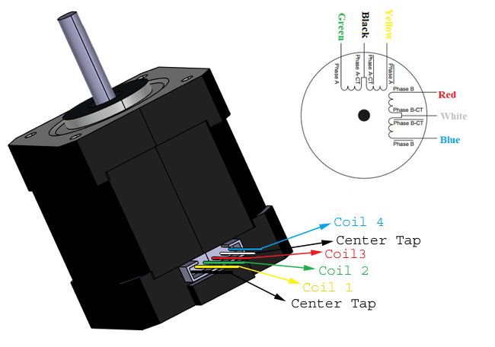

* Agitator Motor – Nhat

**Sensor Team: Matt, Amy, Cody, Wilson**

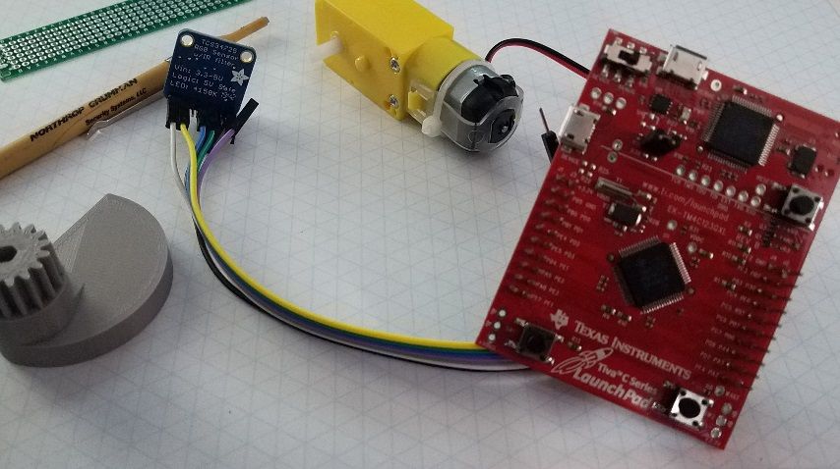

Team Lead: Cody

* I2C Color Sensor – Amy Swanson, Cody Birkland
* Camera/Image Processing R&D – Matt Sheldon

**User Interface Team: Michael, Chris. Nhat**

Team Lead:

* LCD R&D Michael
  + 7 segment display for now?

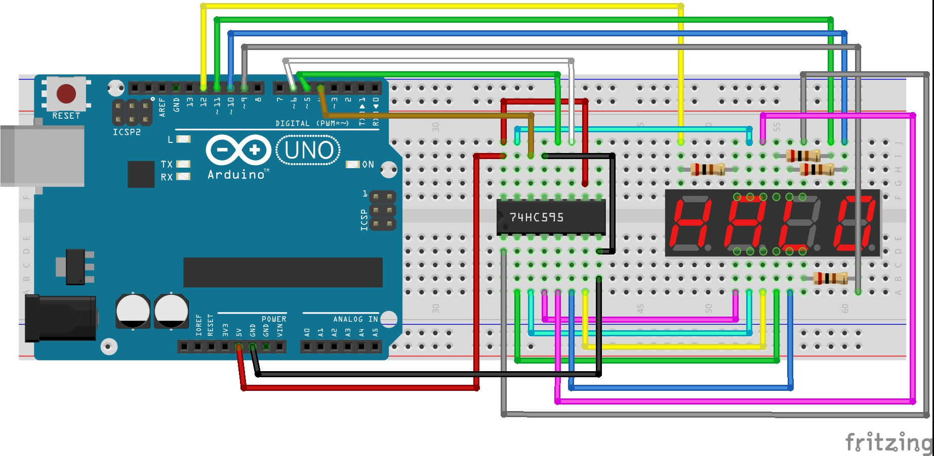

* Stack Light: Michael

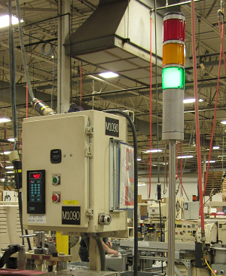

* Operator Panel – Define switches for control, Define Lights/signals for operation and debug
  + User Interface: Start, Stop (switch), Home (mechanical), E-Stop, Preset (lamp),

Software reset, Debug Mode (switch)

* + Motor Control – “homing” lamp, “ready” lamp
  + Color Sensor – mostly called by software (“sensing color” lamp)
  + Camera calibration when camera is implemented
* RGB LED driver with hex inputs Chris, Michael

**System Controls Team: Wilson, Cody**

Team Lead: Pending

* Controls Design and Planning
* Mechanical Design – Cody Birkland
* Power System Design (discuss with motor control team)
* Safety Circuits and Controls

**Schedule:**

Mid-august: Presentable system components

September: Basic working system

|  |  |  |
| --- | --- | --- |
| ~~bench test color sensor to motor interface~~ |  | 8/2/2020 |
| Design outline of control systems |  | 8/30/2020 |
| finished mechanical prototype |  | 8/30/2020 |
| Implement basic user interface |  | 9/13/2020 |
| integrate camera and image processing |  | 9/27/2020 |

**Next Steps:**

* Communicate current system design to user interface team (Cody, Jaidon)
  + Call Diagram
  + Refine Color Sensor code
* Continue mechanical design: chute home switch mount, color sensor mount (Cody)
* Documentation for TM4C programming – setup tutorial (Jaidon: Linux, Amy: Code Composer, Cody/Jaidon: Figure out Visual Studio)
* Prototyping various methods for interfacing: Stack light, UART, 7-segment, etc (User Interface Team)
* Hopper Design and Agitator Motor circuit design (Jaidon and Motor Control Team)
* MISRA C Style Guide PDF £10-20 (Amy talk to Uri) or “ReadTheDocs” designs – discuss in August 4th group meeting
* PLC request from Dr. Walsh (Cody August 3rd)
* Start developing Camera interface (Cody, Matt)

**Notes:**

Yakindu logic diagram software

